Experiment – 16

Create a Cloning of a VM and Test it by loading the Previous Version/Cloned VM using vmware workstation.
AIM:
To create and verify a duplicate copy of a virtual machine using VMware Workstation.
SOFTWARE REQUIRED:
VMware Workstation 17, Ubuntu ISO, Host OS: Windows
PROCEDURE:
- Open VMware Workstation 17 from the Start menu to access the virtualization platform on the Windows host system.
- Begin creating a new virtual machine by selecting the option to create a new VM and choose the “Typical (recommended)” configuration to proceed with a standard setup.
- Select the operating system installation source by choosing the installer disc image file (ISO) option and browse to select the Ubuntu ISO file required for installation.
- Assign a suitable name such as “Virtual Machine Ex-16” to the virtual machine and choose an appropriate storage location before continuing.
- Complete the configuration by clicking Finish, allowing the Ubuntu operating system to begin installing automatically within the virtual machine.
- Save the settings and power on the virtual machine to ensure the operating system is properly installed and functioning.
- After verifying proper operation, shut down the virtual machine completely to prepare it for the cloning process.
- Initiate the Clone Wizard by right-clicking on the virtual machine, selecting Manage, and then choosing the Clone option.
- Select the cloning method by choosing the Full Clone option, which creates an independent and complete copy of the original virtual machine.
- Provide a name such as “Clone of Virtual Machine Ex-16” for the duplicated machine and specify its storage location.
- Complete the cloning process by clicking Finish, and then power on the cloned virtual machine to verify that it operates independently of the original system.

IMPLEMENTATION:

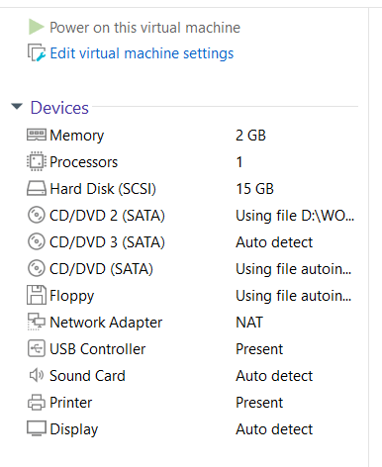

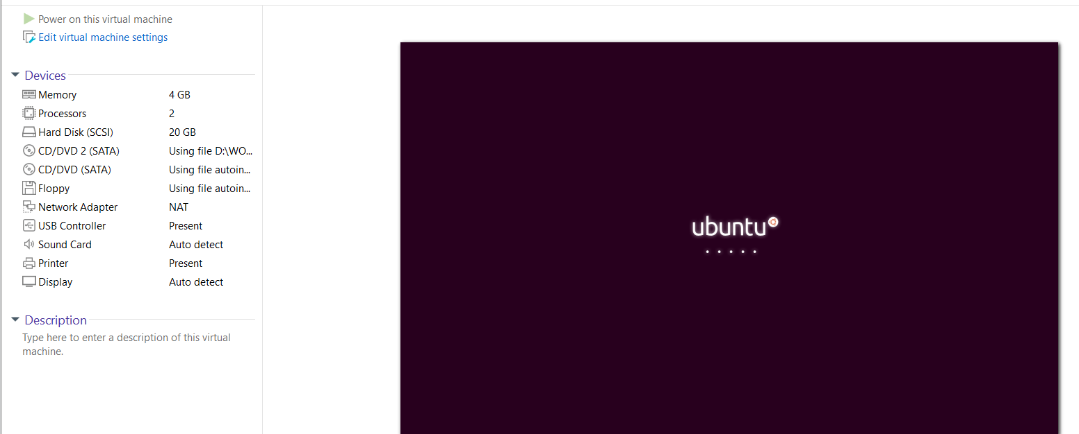

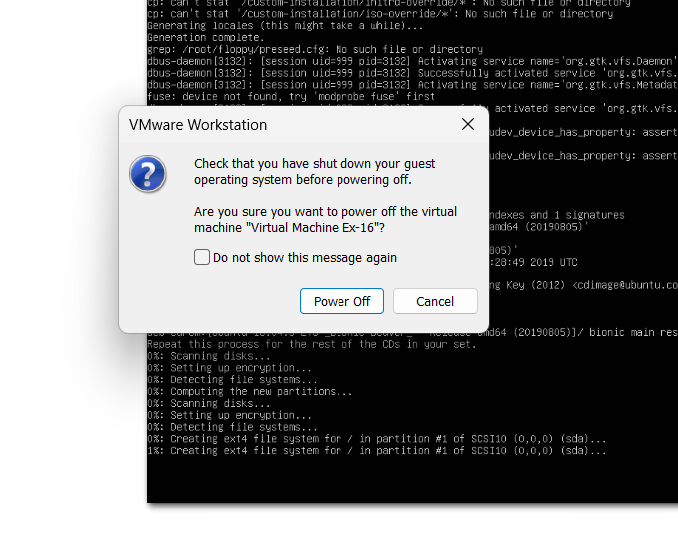

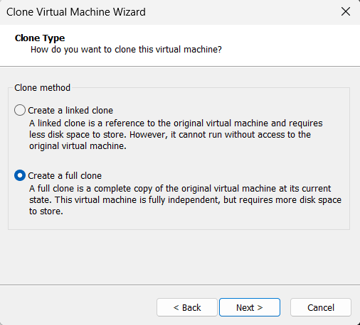

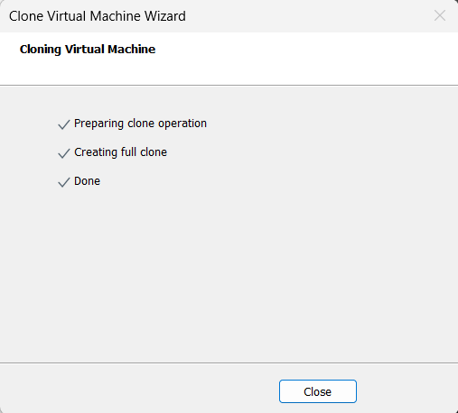
RESULT:
The virtual machine was successfully cloned using the Full Clone option, and the duplicated system was tested to confirm that it functions independently and correctly.

